Orchid Risk Management Course Joining Instructions

Thank you for registering for your course at Orchid Risk Management Training Centre. Below you will find important information to help you get the most out of your course. A course programme may be included if required for your information, along with ‘Find Us’ travel information below which includes a map and ‘Find Us Link’.

Getting to Orchid Risk Management Training Centre

Contact Details:
Orchid Risk Management Training Centre Tel: +44 (0)1202 692 250
Unit 25 Albany Business Park Email: enquiries@orchidrisk.com
Cabot Lane Web: www.orchidrisk.com
Poole How to Find Us:
Dorset
BH17 7BX

Orchid Risk Management Training Centre is located approximately 3 miles from the centre of Poole.
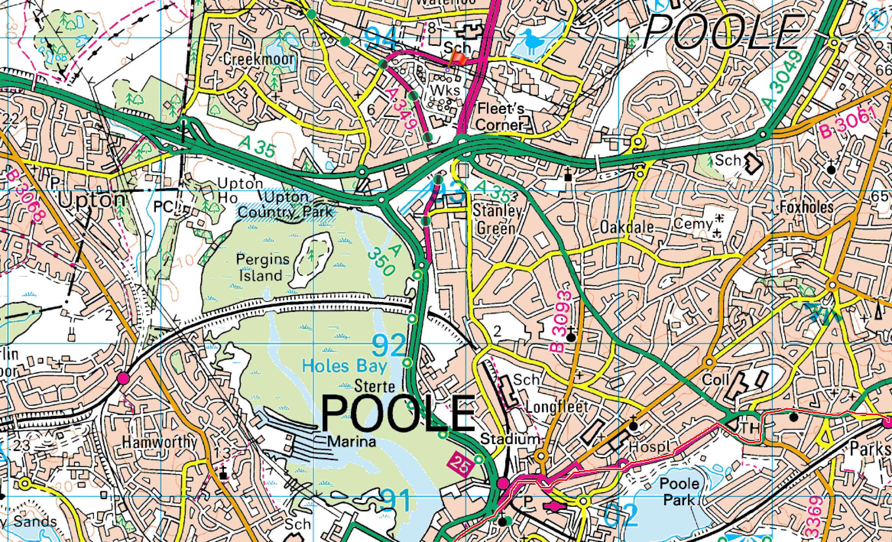
Poole Train Station
Orchid Risk Management Training Centre

By Train
Poole railway station is on the South Western Main Line serving the town of Poole in Dorset, England. The station is situated in the town centre next to Holes Bay. It is one of four stations in the Borough of Poole. Train times, journey times and prices can be found at the following website:
https://www.thetrainline.com

By Taxi
If you have luggage, you may prefer to take a taxi from central Poole station and be taken directly to the location of your choice, if you travel straight to the Training Centre there is adequate storage for your luggage until you leave to your respective accommodation at the end of day.
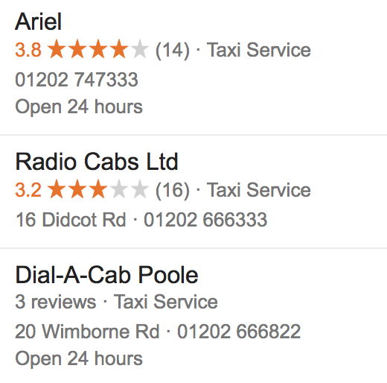

By Bus
Traveline offers independent timetable and journey planning information for the south-west region, both through the Traveline web-site and through a telephone call-centre: 0871 200 22 33 (calls from landlines cost 10p per minute). Information may also be obtained from the bus operator by contacting them directly (telephone numbers below).
Don’t forget, for the latest up-to-the-minute information on bus departures, look for the Real Time Displays at many stops.
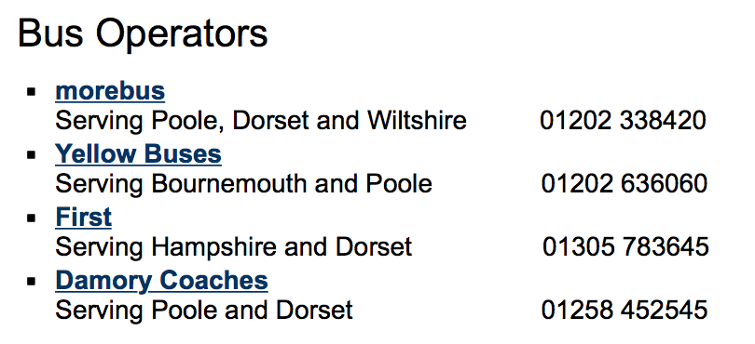

By Air
Poole can be easily accessed from Bournemouth and Southampton Airports using Taxi’s or Busses please check prices and timings prior to your journey.

By Car
The centre is located on the A349 and can be accessed by major UK routes from the North A74 Scotland, M6 & M5 (A350), M1 & M40 (A34 & A31) and travelling from West or East M4 (A350), M3 & M27 (A31).
*It is worth noting that parking is very limited and it is advised that you leave your car at your accommodation in order to avoid parking fines or conflict.

Accommodation whilst on course

Accommodation is not included in course fees. There are numerous hotels in the area to suit your needs and budget. Local hotels can be found online.
http://www.premierinn.com/gb/en/hotels/england/dorset/poole/poole-north.html?cid=GLBC_POOPTI

please note that costs vary and should be booked prior to arrival. The closest hotel is Premier Inn, Poole North on Cabot Lane (BH17 7BX) and is a 9-minute walk and cost from £68 per night (at time of publication of this document).

http://www.premierinn.com/gb/en/hotels/england/dorset/poole/poole-north.html?cid=GLBC_POOPTI

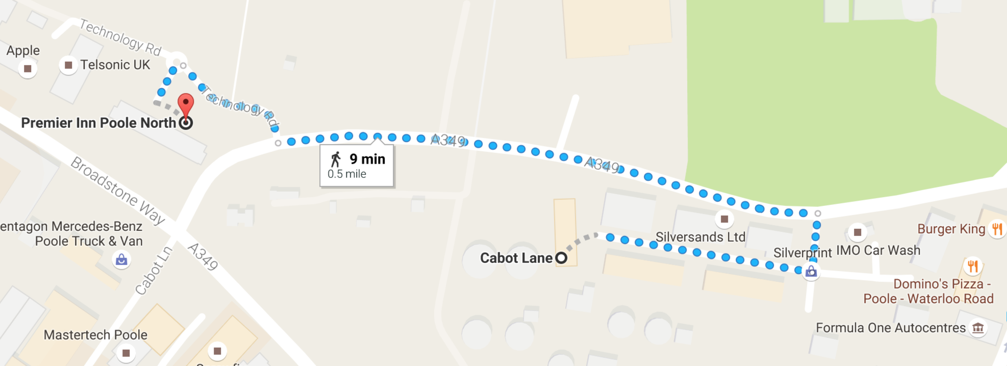

Food and Entertainment
Whilst on your course, there are numerous local restaurants and fast food providers. There is a Tesco’s superstore located nearby (with passport photograph machine and free cash withdrawals). Some fast food providers are located within a 10-minute walk and the closest being Burger King which is a 5 minute walk and Dominos and Subway within 6 minutes.

Tea and coffee will be provided.

Poole Town centre and surrounding areas have numerous and varied entertainment venues and it is advised that you research the facilities before your arrival or speak with your instructors or local residents.

Course Information & Delegate Requirements

Candidates should forward completed course registration forms as provided at least 5 working days prior to the commencement of your course, please contact us if you experience any difficulties.

Assembly
In order to ensure smooth running of the course all delegates are required to be at Orchid Risk Management Training Centre at the following times on the first day of course (unless directed otherwise by your course instructor):
- First Aid and Medical Courses: 09:00
- All other courses: 08:30
It may be worth considering arriving at your chosen accommodation the night prior to the commencement of your course if your journey is considerable as traffic can become congested and increase journey times substantially during rush hour.
Course Duration
The duration of each course and the required guided learning hours is stipulated and regulated by the respective governing body for your chosen course. Each day of First Aid and Medical Courses will last no longer than 9 hours including lunch and breaks, however other courses i.e Close Protection Courses may exceed 10-12 hours per day and evening attendance is required.

Dress
Candidates should consider the following clothing for their course (this list is not exhaustive):

Medical and First Aid Courses:
- Comfortable and non-restrictive clothing to ensure ease of movement during practical sessions.
- Comfortable and stable footwear to allow for safe movement and manual handling.

Close Protection Course Only:
- 1 x suit.
- Smart shoes (no leather soles).
- 3 x shirts and ties.
- Physical training kit (a personal requirement).

All Other Courses:
- Smart/casual clothing suitable for your environment and activities.

*Please note that clothing displaying controversial images or text that may cause offence will not be permitted on any training course.

Other Suggested Items
- A4 or A5 notebook.
- Pens.
- Pencil.
- Laptop (wi-fi is available).
- Mobile phone (including charger and ancillaries) & applications.
- UK driving licence and passport.
- Up to date curriculum-vitae (CV) and relevant certificates.

Physical Fitness:
Candidates attending Orchid Risk Management Training Courses should hold the following fitness levels:
- Close Protection Training Course: delegates are required to have a basic level of fitness. The minimum standard required by Candidates is agility for movement between foot and vehicle drills.
- First Aid and Medical Training Courses – delegates should have the ability to conduct prolonged periods (up to 6 minutes) of Cardio Pulmonary Resuscitation (CPR) in the kneeling position and conduct basic manual handling techniques including placing a live model into the recovery position and assist in placing a casualty onto a stretcher.

Health and Safety:
Orchid accepts no liability for any loss of personal belongings or accident/injury caused as a result of Candidates negligence while attending an Orchid Training Course. Individuals with a medical condition or suffering from any illness should inform the Training Staff upon course assembly on the first day of the relevant Course (this information will be treated as confidential).

